Micro Hydroelectric

Outline of Energy

Definition
Moving water possesses kinetic energy, due to its motion, which has the ability to be harnessed and used for productive purposes. The power of moving water was used anciently to power the grinding gears of grain mills in order to make flour. Though the need for grinding mills has since passed, the need to harness that energy in an efficient, cost effective, and environmentally friendly way is still very much in demand.

Description
Hydroelectric energy is the production of mechanical energy by passing water through a hydraulic machine that is rotated by the action of water and the machine in turn rotates an electrical generator to produce electrical energy. One of the most well known producers of hydroelectric energy within the United States is the Hoover Dam.

Requirements
In order to have an effective micro hydroelectric project it is necessary to have a source of moving water. After a source has been found a water conveyance system is needed to either channel or pipe the water to a turbine or waterwheel that connects to a generator, which in turn produces electrical energy. In order to control the resulting energy levels a regulator is needed. Lastly, wiring is required in order to conduct the electricity to storage locations.

Outline of Technology

Available Options
Hydroelectric energy has been utilized for many years and several different harnessing methods have been developed in order to take advantage of nearly any water source.
Run-of-the-river systems simply divert water from a river or stream to a turbine. After passing through the turbine the water is then fed back into the original water source. This system can be most cost-effective in areas that already have dams in place that want to provide energy. There is also an added benefit of a low environmental impact due to the simplicity of needed materials.
Impoundment involves the use of dams to store and hold water. Many of the large-scale hydroelectric projects utilize this method due to the large amounts of energy that can be provided. However, this method has a large negative impact on the surrounding ecosystem.
Pumped storage involves pumping water that has already passed through the turbines back up into a storage pool. This allows the energy provider to release water during times of high-energy consumption and retain water during low levels of consumption. This method also has a substantial environmental impact.

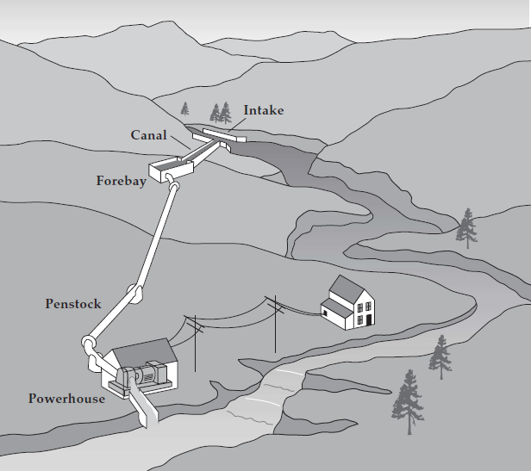
Figure 1

Case Studies

Logan, UT
Logan, Utah, located at the mouth of Logan Canyon, is ideally situated for hydroelectric power. In 2003, the City of Logan hired Stanley Consultants of Salt Lake City, Utah, to provide a more in-depth study of eleven sites within Logan’s existing culinary and irrigation supply system as potential micro hydro sites. However, due to the variance in flow rates, only one of the sites showed a payback of less than 20 years, although four others were considered potentially viable. Stanley Consultants estimated that 800,000 kWh could be produced annually at this site. This would result in $47,200 of annual income for Logan City. The project was estimated to have a cost of $528,000 and a payback of roughly 12 years. The final cost of the project was $1.4 million. The micro hydro project is expected to produce 750,000 kWh a year, which is the equivalent of $30,000 to $50,000. The expected simple payback will range from 14 to 24 years. The maintenance costs are estimated at $5,000. The life of the turbine is about 25-30 years depending on how much sediment is in the water.

Pleasant Grove, UT
Pleasant Grove hired Water Works Engineers to conduct a similar study of their city’s potential for micro hydro projects. In the fall of 2009, the Battle Creek area was identified as having the best conditions for a micro hydro application. Due to the unique variations in water flow, Pleasant Grove wanted to investigate newer micro hydro technologies in order to reap the greatest benefit of the system. With the development of a system using new technology, Pleasant Grove believes it may be able to take advantage of many other sites in the city’s culinary water system. The City estimates that it could produce 1,072,801 kWh of electricity annually. This would be enough energy to offset the current electrical consumption for all of the city’s municipal buildings. Financially, the city expects a potential payback in as little as five years.

Geographical Requirements
The most important requirements in determining whether a particular site is economically viable are whether it has sufficient head and flow to produce enough energy. Head is the height difference between the starting point of the forebay and the location of the turbine in the powerhouse. Flow, usually listed as gallons per minute, is how much water passes through the water source within a set amount of time. The amount of possible energy production is dependent on having sufficient levels of both head and flow. An ideal location has both large head and large flow thereby having the greatest potential for maximum energy output from the micro hydro system. Low head and low flow sites can still produce energy but the payback period would be so long as to make it not economically viable.

Energy Output Levels
In order for a hydroelectric project to qualify as micro hydro, the energy production level must be under a 100 kW threshold. Any system that produces more than 100 kW of energy is then considered small hydro. Breaching the energy threshold introduces additional legal and permit related issues.

Pollution, Byproducts & Environmental Impact
Small, run-of-the- river projects are free from many of the environmental problems associated with large-scale projects because they use the natural flow of the water, and thereby produce relatively little change in the water flow. The dams built for some run-of-the-river projects are very small and impound little water, and many projects do not require a dam at all. Therefore, effects such as oxygen depletion, increased temperature, decreased flow, and rejection of upstream migration aids, like fish ladders, are not problems for many run-of-the-river projects.

Legal Requirements
To install and operate nearly any hydropower project, regardless of its size, requires various permits. The Federal Energy Regulatory Commission (FERC), which has jurisdiction over the entire country, requires application and permit for projects, which produce more than 5 megawatts of electricity. However, micro hydro falls into an exemption category with FERC because of its small energy output. Therefore federal permits are not required, however states still require their own permits. The Idaho Department of Environmental Quality requires that each project receive a certification that verifies that the state’s water quality standards are not violated. Upon receipt of the certification it is then possible to begin installation. There are no limits as to those who can or cannot install, maintain, or use a micro hydro system since most of its applications are with individual homes and small communities.

Operators and Suppliers of Energy Technology

Operational Costs
Since each micro-hydro site differs in capacities, which results in varying complexity of equipment, the cost is not consistent at any given site. Between the cost of materials and labor, if outsourcing labor, the total up-front investment could range of $10,000 - $30,000. The operation and maintenance costs of hydropower are between 1.5% and 2.5% of investment cost per year. The above stated initial investment amounts would give way to yearly maintenance costs of $150 - $750. The current going price per kilowatt-hour is 6.49¢.
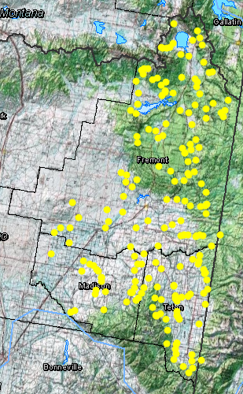

Feasibility

Geographical Availability
The map to the right, which contains the Idaho counties of Fremont, Madison, and Teton, has yellow dots representing potential micro hydro locations. There are a total of 197 different locations that would satisfy the power potential range of micro hydro projects. Included in Appendix A is a list of the coordinates.

Ecological Impact:
As was noted earlier under Pollution, Byproducts & Environmental Impact, the impact a micro hydro system at any one of these locations would have on the environment would be minimal. Due to the nature of micro hydro and run-of-the-river applications there would be no need for dams or other damaging equipment.
Figure 2

Sustainability

Cost
The cost to sustain a micro hydro system in any of the three Idaho counties would be limited to the maintenance costs and the upkeep of the state permits. These costs vary depending on the size and complexity of the system.

Benefit
As long as the water continues to flow through the rivers and streams of Idaho there should be an almost unlimited sustained amount of energy that can be tapped into. Hydropower is one of the only power sources that has a near perfect steady flow of energy at all hours of the day all year round.

Conclusion and Recommendations
Due to the ease of installation, availability of locations, sustainability of the resource, and low maintenance cost makes micro hydroelectric energy a viable option for providing green energy to the area of southeastern Idaho. However, because micro hydro energy is a small-scale project the amount of energy created is also minimal wherein only a few individuals or businesses would benefit. The resource is sustainable but the jobs it would create would be few even if multiple sites were developed throughout the region because of low maintenance requirements. The desire to provide a self sustaining, job creating, green energy source that will impact the region most likely would not be achieved through the use of micro hydro. Larger scale hydro projects would be more capable of providing the cash flow needed to attain the degree that is sought after.

(Warnick, 1982)
(Laboratory N. R.)
(Program, 2011)
(Lab, 2010)
(Lab, 2010)
(Warnick, 1982)
(Laboratory N. R.)
(Laboratory N. R.)
(Commission, 2012)
(Quality, 2011)
(Energy, 2010)
(Program, 2011)
(Research)
(Laboratory I. N.)

