Natural Gas

Outline of Energy

Definition
Natural gas is a fossil fuel, meaning it is formed from the remains of plants, animals and microorganisms that lived millions of years ago. In its purest form, natural gas is an odorless, colorless, and shapeless gas. Natural gas is a composition of hydrocarbon gases, primarily methane. The composition of natural gas varies (see Figure 1 for a composition of gases). When burned natural gas creates a lot of energy with very few emissions.
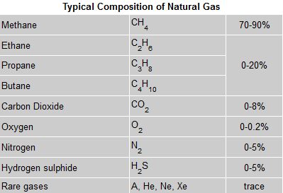
Figure 1

Description
Natural gas is commonly used to heat our homes and cook food. The recent drop in price of natural gas has generated a lot of interest in natural gas powered vehicles and natural gas to generate electricity for communities. Natural gas is found in reservoirs underneath the earth. Production companies search for evidence of these reservoirs by using sophisticated technology that helps find the location of the natural gas, and drill wells in the earth where it is likely to be found.

Requirements
There are a lot of resources needed to create power from natural gas. Natural gas power facilities have fairly advanced technology. A very important and obvious requirement is a steady supply of natural gas. The facility would need to include a turbine and/or a boiler.

Outline of Technology

Available Options
There are three main turbine designs to generate power from natural gas. The first design is a traditional steam turbine. A traditional steam turbine relies on boilers that burn natural gas to heat the water that creates the steam that spins the steam turbine.
The second design is a simple-cycle combustion. Simple-cycle combustion is similar to a jet engine and uses a gas turbine to convert the heat energy of combustion into mechanical energy, which then operates an electrical generator.
The final is a combined-cycle combustion design. A combined-cycle design features heat recovery boilers that take the exhaust heat at approximately 1,125 degrees Fahrenheit from a gas turbine and converts it to steam. That steam goes through conventional steam turbines to generate more electricity, which creates additional efficiencies compared to simple-cycle combustion turbines and conventional steam power plants.

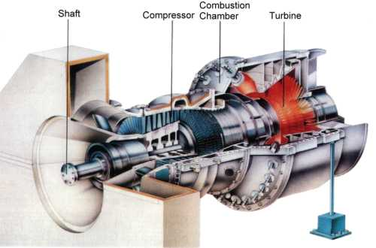
Figure 2 Gas Turbine
The above image is of a natural gas turbine from General Electric (GE). This turbine works by burning the natural gas and spinning very fast. There is a power generator that creates electricity from the spinning. This is almost exactly the same design as a jet engine. These turbines can range is from 300 horsepower (hp) to 268,000 hp. There are three major parts of a gas turbine. There is a compressor which compresses the gas up to 30 times ambient pressure and then the air is released into the combustion chamber. Inside the combustion chamber temperatures can reach up to 2600˚F. The combustion chamber spins the turbine which creates the electrical energy. A simple turbine design has a thermal efficiency ranging from 15-42%. The thermal efficiency is defined as the ratio of used energy from the turbine to the fuel energy input.

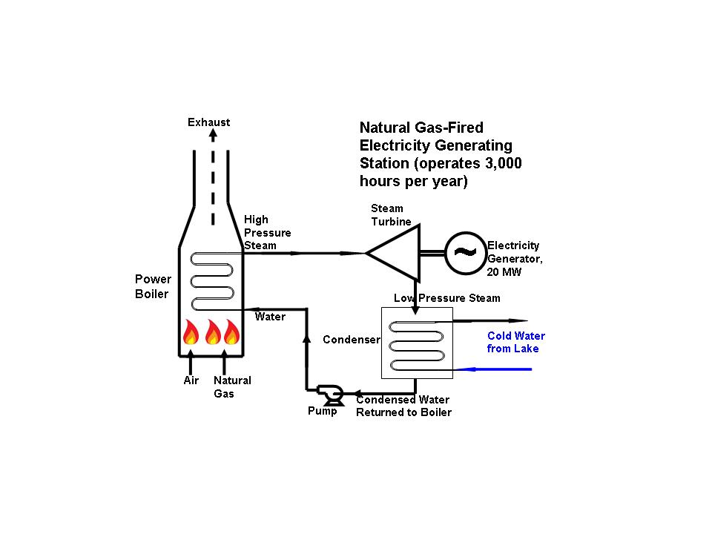
Figure 3 Boiler/Steam Turbines
In the design above, natural gas is used to heat a boiler of water. The water is used to generate steam which powers a steam turbine to generate electricity. Out of the three types of layouts, this is the least efficient. There is also some controversy with this design because the water gets so hot it will sterilize the water from a lake or river.
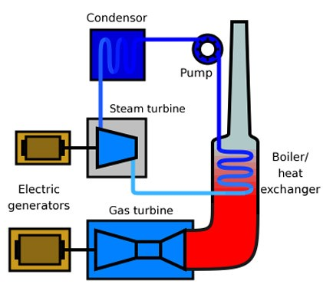
Figure 4 Combined Cycle
The design of a combined cycle natural gas facility is much more complex but reaps a remarkable thermal efficiency of up to 60%. The turbine works the same as it would in a simple combustion layout, but there is a boiler that that absorbs part of the 2600˚F produced from the turbine. Usually a plant will have a supplementary-fired boiler that can be used to increase the steam production.

Case Study
Southern Montana Electric (SME) is currently in the process of a two-stage project to build a natural gas power-generating facility. The first phase was to build a 40 MW station that uses a simple cycle combustion turbine generator. This portion of the project is complete and in 2014 or 2015 construction will begin to upgrade the plant. The upgrade will boost capacity to 120 MW. SME states that the project will bring 300-400 additional workers.

The second phase of the project will build one more additional simple cycle natural gas-fired CTG, two additional gas compressors, two additional generator step-up transformers, and one additional unit auxiliary transformer. Further, Phase 2 will include the addition of combined cycle equipment including two Heat Recovery Steam Generators (HRSG’s) with natural gas-fired duct burners. The cost of phase one of the project was $85 million. SME was intending on borrowing up to $215 million for phase two.

Late 2011, SME surprised the region when they filed for bankruptcy. It appears that a lot of the bankruptcy issues are related to poor management. According to an article in the Billings Gazette " Three members of Southern's six-member board said they were blindsided by the surprise bankruptcy filing, which came hours after a tumultuous meeting in which half of the members walked out to protest the board's refusal to seat a new trustee from a member cooperative." There were also issues with the city of Great Falls on the subject on water rights usage.

Geographical Requirements
There are many geographical requirements for a natural gas facility. One of the biggest requirements is to be near a large source of natural gas. If the layout requires a boiler it will also be important to have the power generating facility be near water source. From the cases I have studied, many of these projects create a simple combustion power generating stations and add additional combustion turbines in a future state while upgrading them both to a combined cycle design. In the Montana case it mentioned that the station would cause noise pollution. The Montana station also required six acres.

Pollution & Environmental Impact
Water: If a combined cycle or a steam turbine design is used, there could be a maximum of 216 gpm of wastewater that must be treated. This water would contain slight traces of boiler water treatment chemicals. Southern Montana Electric would discharge the water back into their lakes and streams because the slight traces were extremely small. There is some concern about the water during the boiler process. The water in the boiler water, that comes from a natural source, is heated to steam. The heat process destroys all living matter in the water. Some of this matter is food for fish or other animals. There is concern that too much of this will have a major impact on the environment.
Emissions: oxides of nitrogen (NOX), carbon monoxide (CO), volatile
organic compounds (VOC), particulate matter (PM), particulate matter with an
aerodynamic diameter less than 10 microns (PM10), particulate matter with an
aerodynamic diameter less than 2.5 microns (PM2.5), sulfur dioxide (SO2), and lead
(Pb).
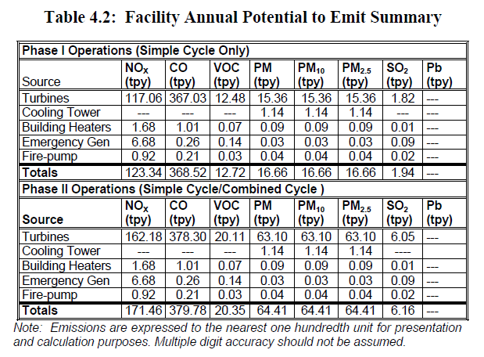
In the Southern Montana Electric case they estimated that operating the facility would result in carbon dioxide (CO2) emissions of roughly 250,000 tons per year (See figure XXXXX).

Operators & Suppliers of Technology

Operational Costs
Depending on the layout, there will be different technologies needed. A combined cycle design would require a gas powered turbine and it would also require a steam powered turbine. The major suppliers of turbines are Westinghouse, General Electric, and Siemens. According to PJM, the operations variable operation and maintenance(VOM) costs for a combined cycle turbine are $2.50 per MWh. For a single combustion turbine the VOM costs are $2.00 per MWh.

Workforce Management
The Highwood employs around 20 full-time people. There are many positions needed for day to day operations. Some of those positions would be maintenance personnel, janitors, etc. Depending on the size of the plant there might need to be people to purchase fuel contracts, arrange financing, and customer support. According to the Bureau of Labor Statistics, the mean salary for a natural gas operator is $59,870. During peak times of construction, Highwood required approximately 320 construction personnel.

Conclusion & Recommendation
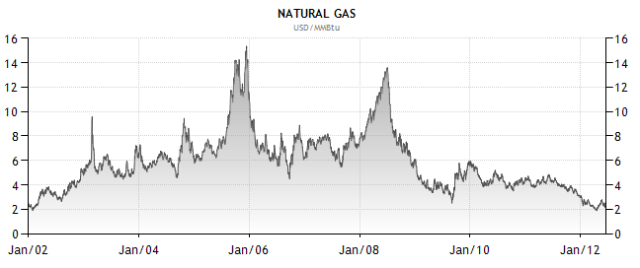
The biggest argument against natural gas is its fluctuation in price. With recent advancements in natural gas mining prices have dropped to a 10-year low. Another difficult struggle for Fremont County would be maintaining a steady supply of natural gas. Highwood Montana built their plan near an existing pipeline and built a connection from the pipeline to their power station. Fremont County would have to work with Intermountain Gas Companies' existing structure.

Natural gas is remarkably clean energy source considering that it is regarded as a fossil fuel. Another plus for natural gas is it is found locally in the United States. Once Fremont County learns how to get a steady supply of natural gas it could open a lot of doors for additional natural gas use. An example of this is compressed natural gas powered vehicles. The 2012 Honda Civic has a natural gas version for $26,000. There are also kits that allow vehicle owners to convert their vehicle to natural gas. Currently Southeast Idaho does not have any compressed natural gas filling stations.
Natural gas is a clean, cheap, and abundant energy resource. Many people in the industry view natural gas as a "bridging" energy source meaning that it is a temporary solution to help move us from environmentally straining resources to more environmentally friendly resources. My recommendation would be to continue to pursue natural gas energy production. An additional study could help clarify some opportunities regarding natural gas availability in southeast Idaho and natural gas vehicles.

(Langston)
(Overview of Highwood Generating Station Project, 2012)
(Johnson, 2011)
(PJM Interconnection LLC, 2011)
(Gas Plant Operators)
(Natural Gas, 2012)

