Geothermal Energy

Outline of Energy

Definition

Geothermal Energy is created by the utilization of groundwater below the surface of the earth, heated by a nearby dormant volcano. The water is heated by the molten rock at depths of up to 9,800 feet. Geothermal operates at up to 95% of its electricity generating capacity year round. The energy is harvested by drilling wells to the depth of the water, separating the steam from the hot water, and sending the steam to the power plant. The water is then returned to the reservoir to generate more harvestable steam energy. This process makes geothermal energy clean and renewable.

Description

There are three common technologies used to extract heat and produce energy from geothermal sources, they are: dry steam, flash steam, and binary cycle. The dry steam process extracts fluids in a gaseous state and runs them through a turbine which powers a generator. The flash steam plant, the most common in use today, involves pumping highly pressurized fluid to the surface where it enters a low pressure tank, which prompts a “Flash” steam reaction to drive the turbine. The binary cycle power plant passes hot water through a heat transfer with a lower steam point liquid which vaporizes and drives the turbines to generate electricity. The different technologies are further discussed in the Available Options section of this document. Geothermal production, like fossil fuels, provides continuous base load energy (meaning it doesn’t need to be stored for later use like resources that do not run continually). This form of energy is renewable because it is derived from a conceivably limitless and renewing energy source, the earth’s heat.

Requirements

Relatively few locations have the conditions needed to generate geothermal energy; there must be a fracture in the earth’s crust which enable molten rock to come close to the surface and heat underground water to a high temperature, there must be enough fluid to fuel the generator, and the ground must be permeable. The type of power plant used to produce energy depends upon the resource, whether it is in a liquid or gaseous state and its temperature. The only operating geothermal power plant in Idaho, the Raft River plant, operates a binary cycle with water at 300°F.

Outline of Technology

Available Options

There are three options that may be considered for a geothermal power plant: the dry steam, flash steam and binary designs. Dry steam plants use hydrothermal fluids that are stored in the earth as steam. Since the hydrothermal resource is already steam, it travels directly to a turbine to drives a generator, bypassing any steam conversion process. Dry steam plants emit some excess steam with very minor amounts of gases (depending on the location and makeup of the resource). A dry steam power plant system was the first type of geothermal power generating technology put into use. Steam technology is used today at the Geysers in northern California, currently the world's largest single source of geothermal power. The main point to keep in mind for this power plant design is that the resource must be naturally found in a gaseous state. Please see the following diagram entitled Dry Steam Power Plant for a visual depiction of the process described.

Flash steam power plants are currently the most common type of geothermal power generator in operation. To be viable for this plant design resource fluids must be at temperatures greater than 360°F. The water is pumped through a high pressure tube into a low pressure tank at ground level, which causes some of the fluid to quickly vaporize, hence the use of the word "flash" to describe the process. From this point the process is similar to that used in a dry steam plant; the vapor drives a turbine which in turn drives a generator. To increase efficiency, any liquid that did not “flash” can be moved to another tank where it can be flashed again and produce more energy. Please see the following diagram entitled Flash Steam Power Plant for a visual depiction of the process described.

Binary cycle power plants are differ from dry and flash steam systems in one main aspect, which is that the resource from the geothermal reservoir never comes in contact with ground level turbine and generator units. To be used in a binary cycle plant the resource needs to have a low to moderate temperature range, usually below 400°F. The geothermal fluid passes through a heat exchange with a secondary fluid that has a much lower boiling point than water, which causes the secondary fluid to vaporize. From here the process is similar to the two technologies already discussed; the vapor drives the turbines, which power the generators, which creates electricity. Binary cycle plants are closed-loop systems, so virtually nothing is emitted into the atmosphere. Resources in the low to moderate temperature range are the most common in the world, concurrently, the binary cycle plant is the technology that is expected to be implemented most in the future. Please see the following diagram entitled Binary Cycle Power Plant for a visual depiction of the process described.

The Standard Steam Trust (SST) has confirmed that the geothermal site in Newdale, Fremont County, ID is a viable site for a geothermal power plant. The location is classified as a phase 1 project, meaning that the resource has been procured and identified. A capacity estimate has not yet been made to determine the potential power supply of the resource in Newdale (find a source for this).

The research already done in the Newdale project has concluded that there is an abundant resource of ground water. Results from the SST project drill holes show yields in excess of 3,000 Gallons per Minute (GPM), most pronounced near the Teton Dam Fault. In some of the holes drilled to depths of 150-200 meters water is confirmed at 100°F. Local irrigation lessors pump over 2,400 GPM of water from wells that reach 124°F.

The Raft River Geothermal power plant (discussed further under the Case Study heading) has a similar temperature range to what has been found in the Newdale project. For this moderate temperature range, the binary-cycle technology is the most feasible option to generate electric power. The closed loop cycle moves the water to the point where it can heat the binary liquid to steam and is then directly injected back into the reservoir to replenish the resource.

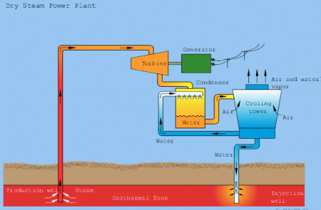

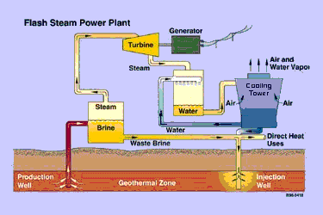

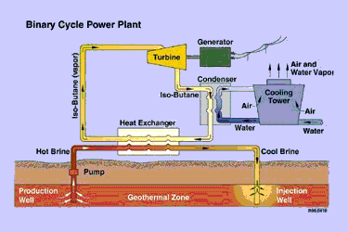

Case Study

The Raft River project, which is located approximately 200 miles SE of Boise, ID, is the only geothermal power plant operating in the state of Idaho. Based on estimates from GeothermEx Inc., the 8 square mile plot of land may be capable of producing 110 megawatts of electricity. The Raft River area was designated a Known Geothermal Resource Area in 1971, and in 1973 the United States Geological Survey and Energy Research and Development Administration (now the Department of Energy (DoE)) began a geothermal exploration program in southern Idaho. Between 1974 and 1980, 84 wells were drilled at Raft River, including 7 deep wells that formed the basis for a geothermal demonstration plant. The first commercial size binary cycle geothermal power plant in the world, a 7 megawatts binary system using isobutane as the binary fluid, was constructed, and tested at this site. This plant operated from late 1981 until June 1982, generating 4 MWe net from geothermal fluids that ranged in temperature between 135-145°C. Due to a change in government priorities, the DoE declared the project a success and decided to sell off the plant equipment.

Although the exhibition plant only produced electricity for several months on a test basis, the technology has since become a proven technology for producing electrical power from moderate temperature geothermal resources in the world. The site was chosen because of the proven hot water resource that had already been developed and tested, and the significant facilities that were already in place. The Raft River site remained untouched for the next 20 years. US Geothermal Inc. acquired the site in mid-2002, and after upgrading existing wells and drilling additional wells, another binary plant was installed. The field began generating approx.10 MWe in January 2008.

The Raft River field contains 9 deep geothermal wells (> 1500 m depth), 4 are currently used for production and 3 for reinjection. Production temperatures are approximately 140 °C, with a total production rate of ~400 kg/s. The production wells generally produce from approximately 1400 m depth on the northwest side of the field, and approximately 1750 m depth on the southeast side of the field.

The Raft River valley is located in Cassia County, southwestern Idaho, on the north-eastern edge of the Basin and Range province and on the southern side of the Snake River Plain (which demarcates the Yellowstone hotspot trace)(Figure 1a). The valley is approximately 60 km long and 20 km wide, and the valley floor lies at an average elevation of 1400 m above MSL (mean sea level). The geology in the valley is complex, and reflects the combined influences of these two geologic terrains. Precambrian metamorphic rocks are found to the west and south in the Albion and Raft River Mountains, and also underlie the Raft River basin where they form the primary reservoir of the geothermal system: lithologies include quartzite, schist and quartz monzonite (Covington, 1980; Williams et al., 1982; Blackett & Kolesar, 1983). To the immediate west lie the Jim Sage Mountains and the Cotterel Mountains, consisting of Late Tertiary rhyolites and tuffs that erupted when the Yellowstone thermal pulse was situated to the north of the Raft River basin (Christiansen and Lipman, 1972). To the east lie the Black Pine and Sublett Mountains that expose allochthonous Paleozoic limestone, siltstone and shale. The Raft River basin consists of ~1800 m of Tertiary and Quaternary infill sediments and volcanic rock overlying the Precambrian basement. The top 300 m of basin fill defines the Raft River Formation, composed of fluvial, alluvial and loess sediments that are lenticular and gradational in nature. The underlying Salt Lake Formation consists of Miocene-Pliocene lacustrine deposits and volcanic tuffs and flows. The basement contact gently dips to the east and is inferred to be a detachment surface (Williams et al., 1982). Two major fault zones have been identified on the west side of the valley: the Bridge Fault Zone and the Horse Wells Fault Zone (Figure 1b). Both zones strike approximately north-south; the faults are\ inferred to be listric in nature, flattening at the basement-sediment contact (Dolenc et al., 1981). The NW production wells are believed to intersect permeable zones associated with the Bridge Fault (or adjacent parallel fault(s)). From geophysical data, another major structure has been inferred to exist beneath the Tertiary deposits - the Narrows Zone, which trends northeast-southwest and has been interpreted as a basement shear (Mabey et al., 1978). The morphology of this zone is not well characterized, however it appears the Bridge and Horse Wells Faults terminate at their southern ends against the proposed Narrows Structure (Mabey et al., 1978; Dolenc et al., 1981). The intersection of the assumed Narrows Zone and Bridge Fault Zone plays an integral role in controlling the location of the upflow zone in the geothermal system.

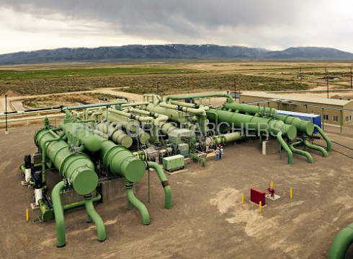

Geographical Requirements

According to the U.S. Department of Energy, the following variables would be required for a location with similar characteristics to the Newdale project:

“...Hot geothermal fluid with low mineral and gas content, shallow aquifers for producing and reinjecting the fluid, location on private land to simplify permitting, proximity to existing transmission lines or load, and availability of make-up water for evaporative cooling. Geothermal fluid temperature should be at least 300º F, although plants are operating on fluid temperatures as low as 210º F… The flow required depends on the temperature of the fluid, the ambient (sink) characteristics, and the pumping power required to supply and dispose of the fluid. Excluding fluid pumping, a closed-loop binary-cycle geothermal power plant would need 450 to 600 gallons per minute (gpm) to generate 1 MW from a 300° F fluid with an air temperature of 60° F. If the fluid temperature were only 210° F, one would need 1,300 to 1,500 gpm to generate the same amount of power.”

Pollution & Environmental Impact
Geothermal power offers many advantages over fossil fuel power generation; including low emissions, an unlimited resource, the possibility to extract minerals from the resource, and low visual impact. The only thing emitted from geothermal flash plants is the excess steam. No air emissions or liquids are released by binary cycle plants, which are predicted to become the principal technology in the future. Minerals that may be in the fluids are injected back into the reservoir with the water at a depth much deeper than groundwater aquifers. This process recycles the geothermal water. Some geothermal plants do produce sludges that require disposal. Some of these solids, such as zinc, sulfer and silica, are now being extracted for sale, which increases the value of the resource. Geothermal heating systems are easily integrated into communities and have very little visual impact. Geothermal power plants use small acreages, are low to ground level, and do not require storage, transportation, or combustion of fuels. The only visible emission would be steam in the plants that give off excess steam.

Operators & Suppliers of Technology

Operational Costs

A binary cycle power plant will be able produce electricity for as little as 7.37 cents per kilowatt-hour after taking into account all related costs and including a production tax credit. There is also potential for direct use of geothermal resources as a heating source for homes and businesses. One potential use of direct geothermal heat is a year round greenhouse, which could offset some of the costs related to building and running the power plant. Operating and maintenance costs (variable costs) range from $0.01 to $0.03 per kWh. Most geothermal power plants can produce energy at least 90% of the time, but running at 97% or 98% may increase maintenance costs. An ability to charge higher prices for the electricity justifies running the plant 98% of the time because the higher maintenance costs will be recovered.

Feasibility

Geographical Availability

Call Newdale project investors and obtain this information*

Ecological Impact

Sustainability

Cost
Costs of a geothermal plant are heavily weighted toward early expenses for research and building, rather than resources to keep them running. Well drilling occurs first, followed by resource analysis of the drilling information, and these two steps have already been completed for the Newdale site. After analysis has been made that prove the viability of the resource is the design of the actual plant. The initial cost for the field and power plant is usually around $2500 per installed kW on average, but in a small (<1Mwe) power plant it will most likely be $3000 to $5000/kWe.

Benefit

Conclusion and Recommendations

(Chevron Corporation, 2012)
(Standard Steam, 2012)
(U.S. Department of Energy, 2012)
(Union of Concerned Scientists, 2009)
(U.S. Department of Energy, 2012)
(Geothermal Energy Association, 2012)
(U.S. Department of Energy, 2012)
(U.S. Department of Energy, 2012)
(U.S. Department of Energy, 2012)
(Union of Concerned Scientists, 2009)
(Geothermal Energy Association, 2012)
(Standard Steam Trust, 2009)
(U.S. Geothermal Inc. , 2008)
(Photo Researchers, Inc., 2012)
(Bridget Ayling, 2011)
(Photo Researchers, Inc., 2012)
(U. S. Department of Energy, 2011)
(U. S. Department of Energy, 2011)
(California Energy Commission, 2003)
(Union of Concerned Scientists, 2009)
(U. S. Department of Energy, 2011)

